**Login Dashboard:**

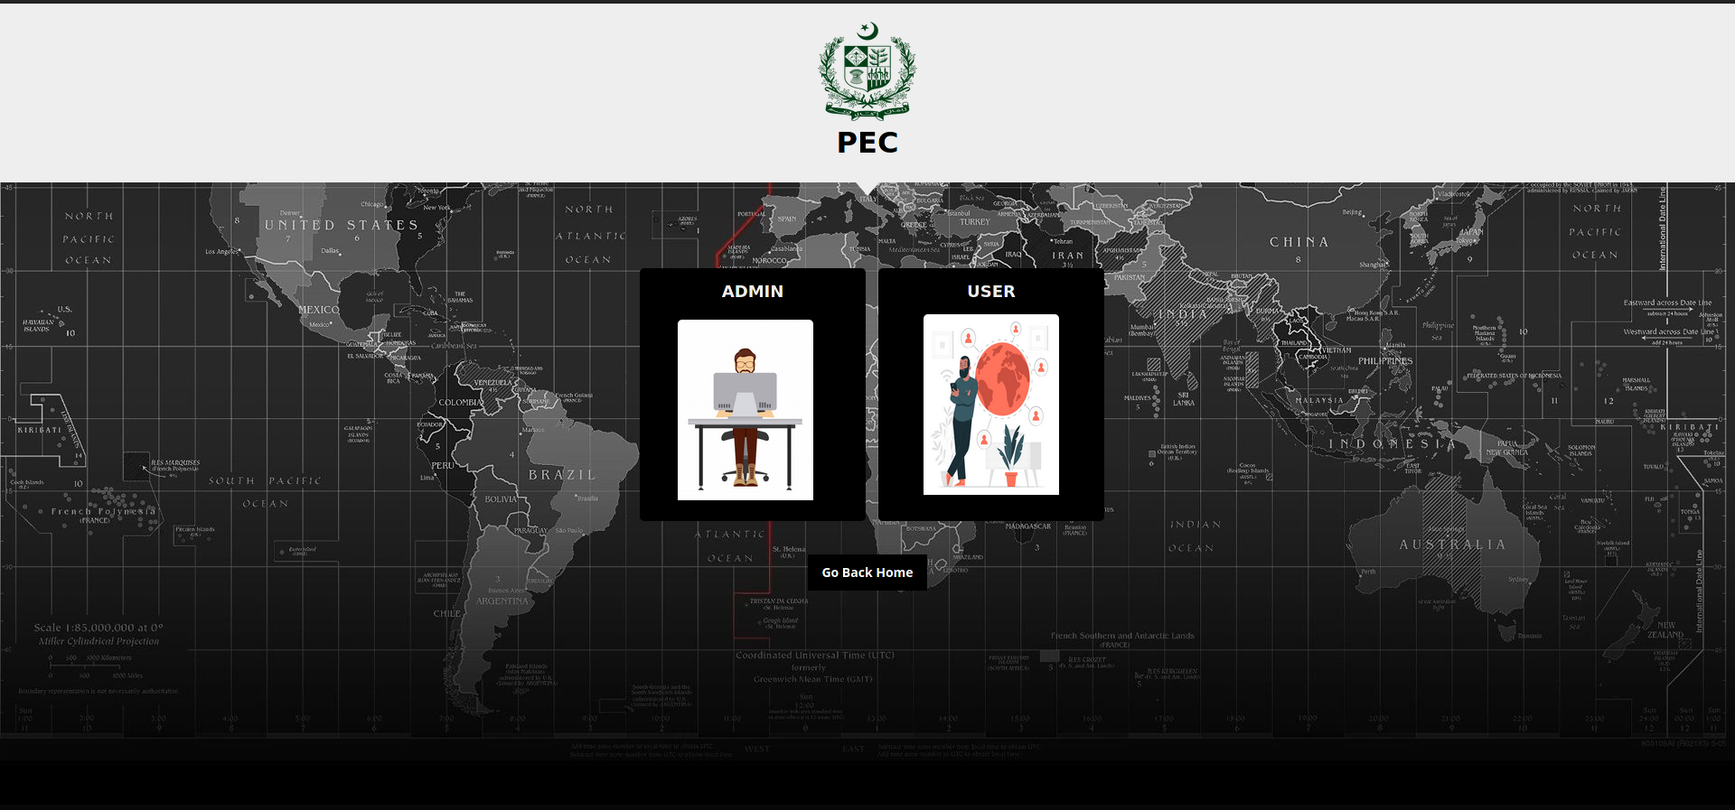

**Description:**

This page contains a view finder for admin and user login page. The page contains two buttons. On the admin button the admin can access the admin login and the user can access the user login page.

**Code:**

**HTML File:**

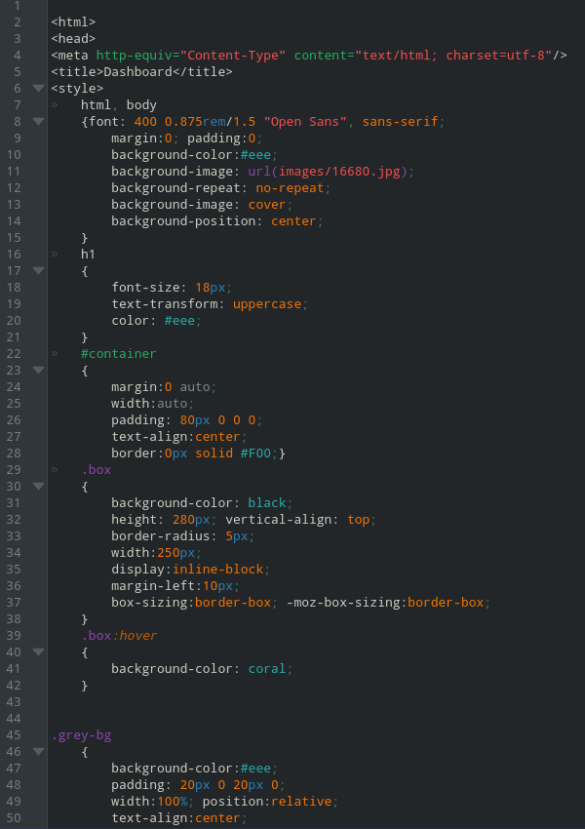

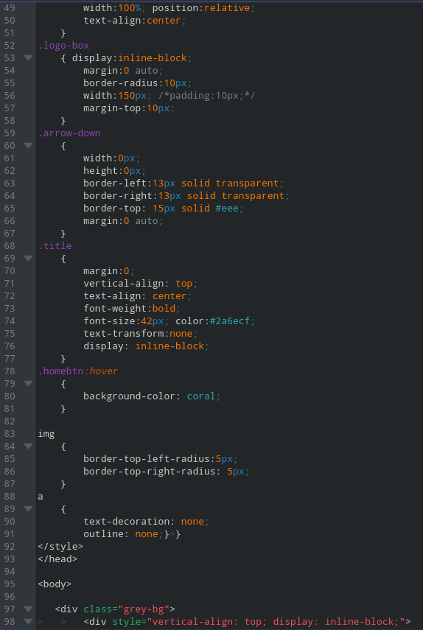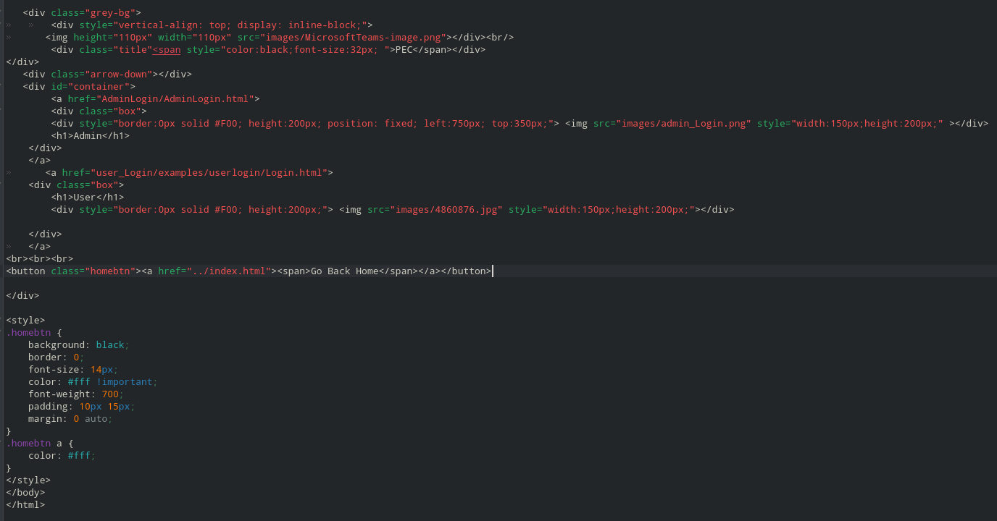

**Admin Login:**



**Description:**

The admin Login contains two labels and a button which gives access to the admin dashboard if the admin username and password is correct. If they are correct then the admin can access the admin dashboard.

**Code:**

**HTML Code:**

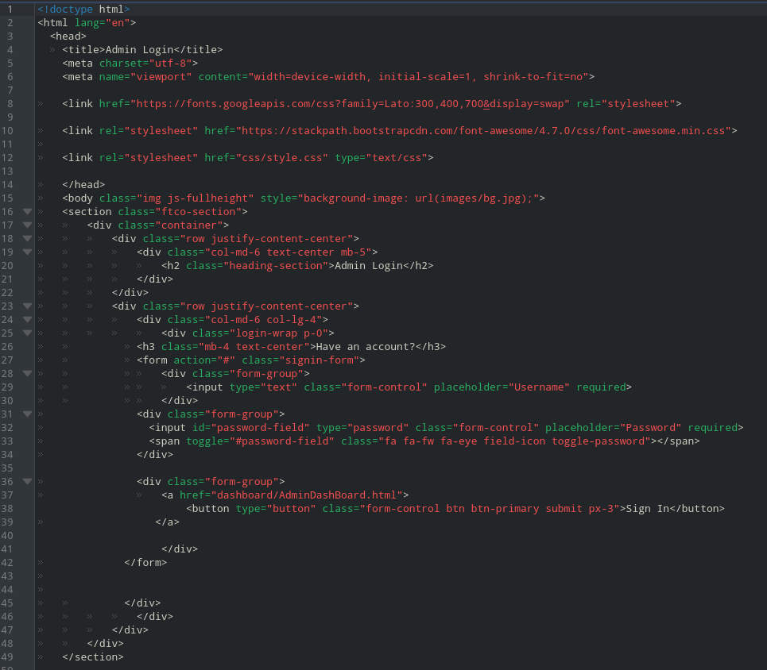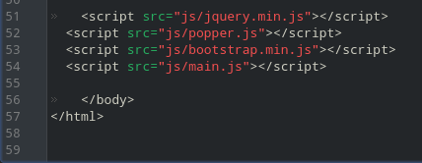

**CSS Code:**

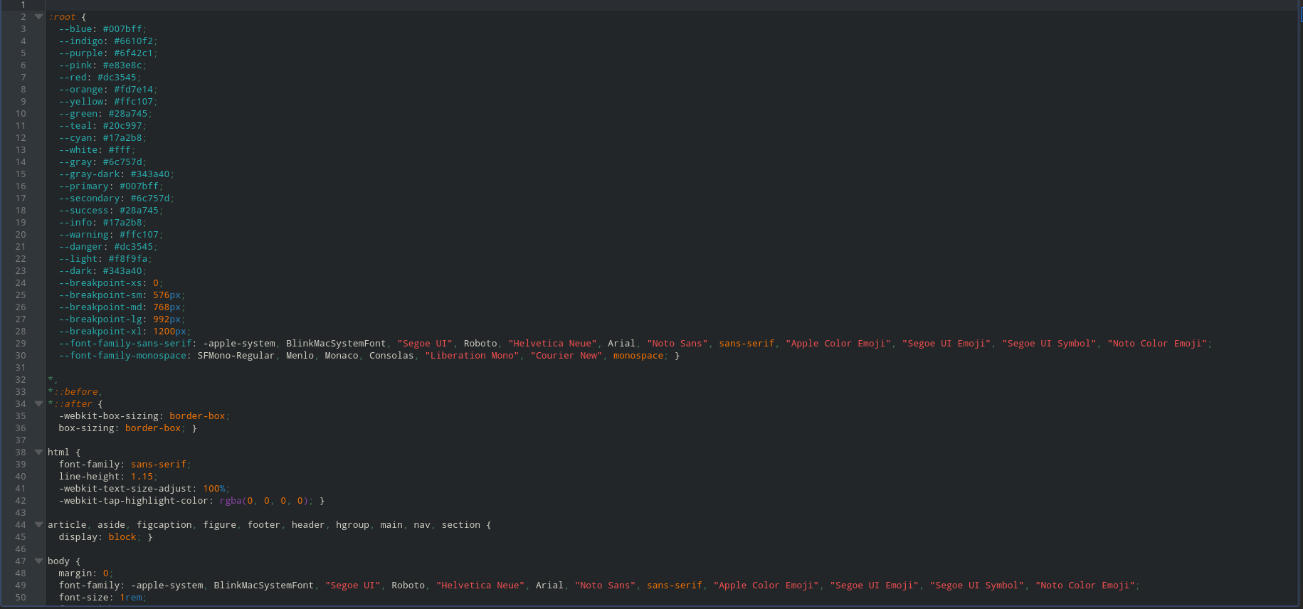

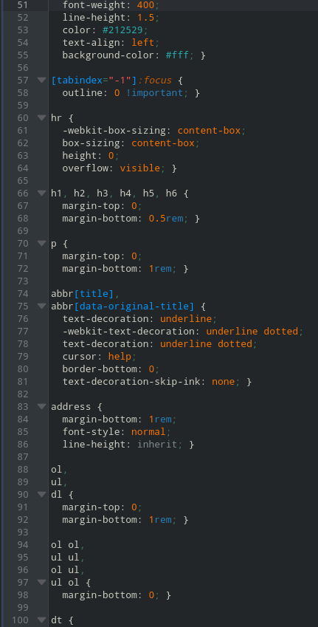

**Admin Dashboard:**

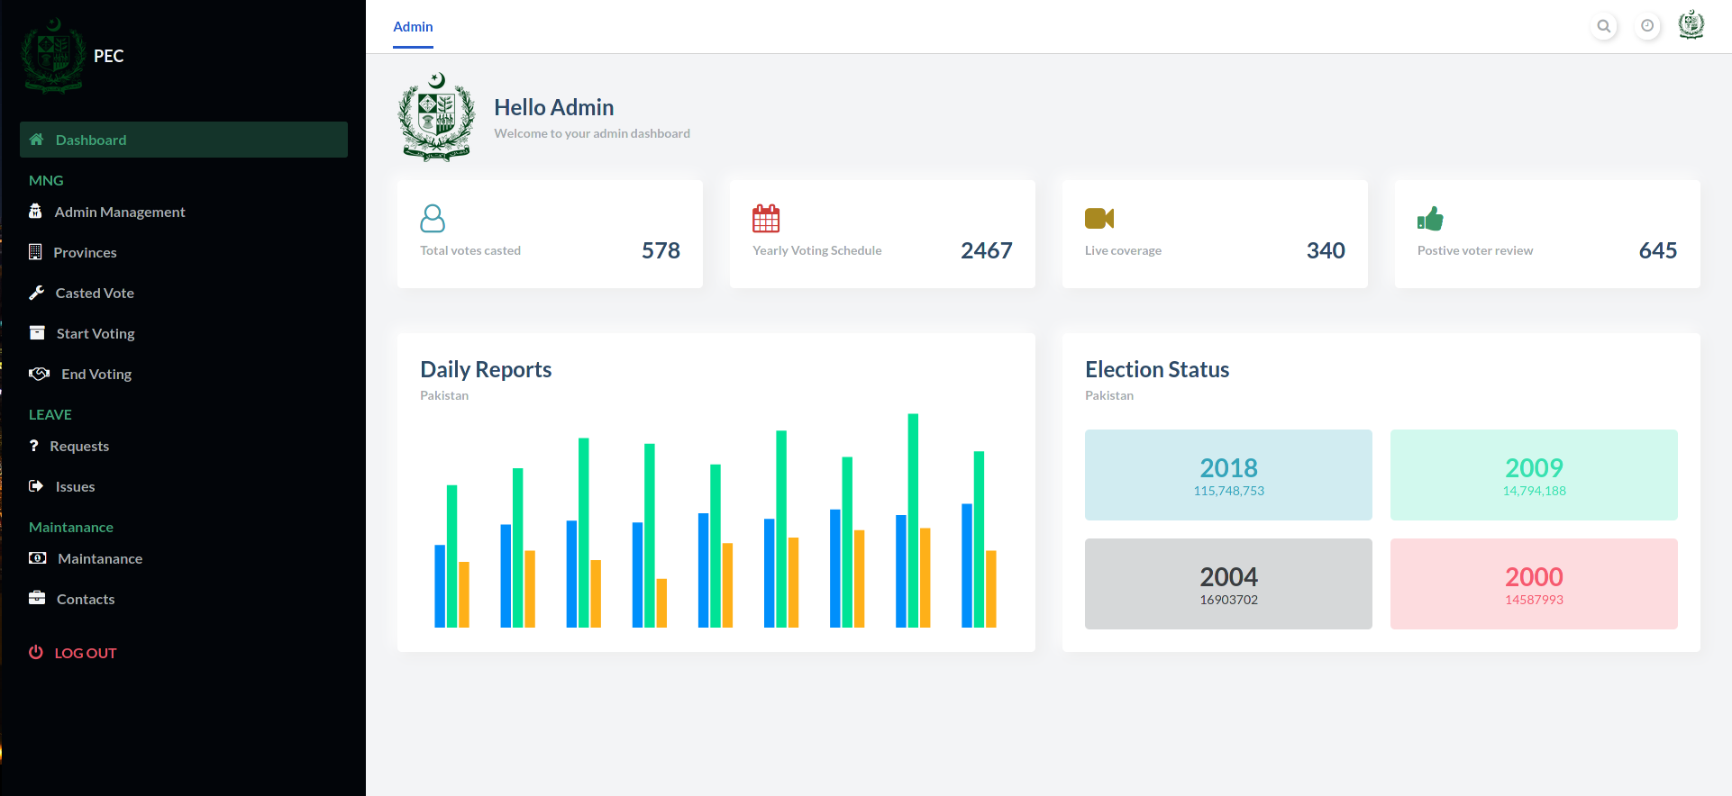

**Description:**

This is the admin dashboard and the admin dashboard there are couple of functions which include management of casting vote and checking for result of elections.

The admin can also view all of the reports of voting, daily basics and the history of previous election as well.

**Code:**

**HTML Code:**

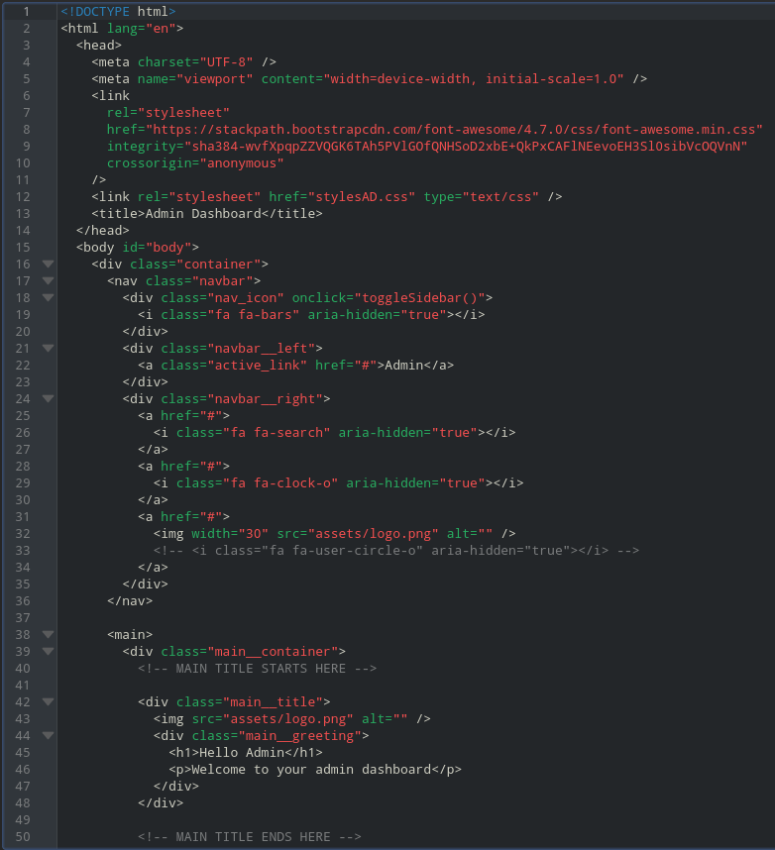

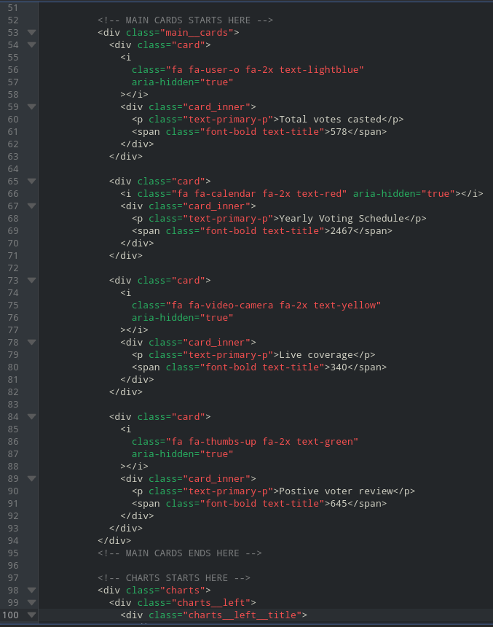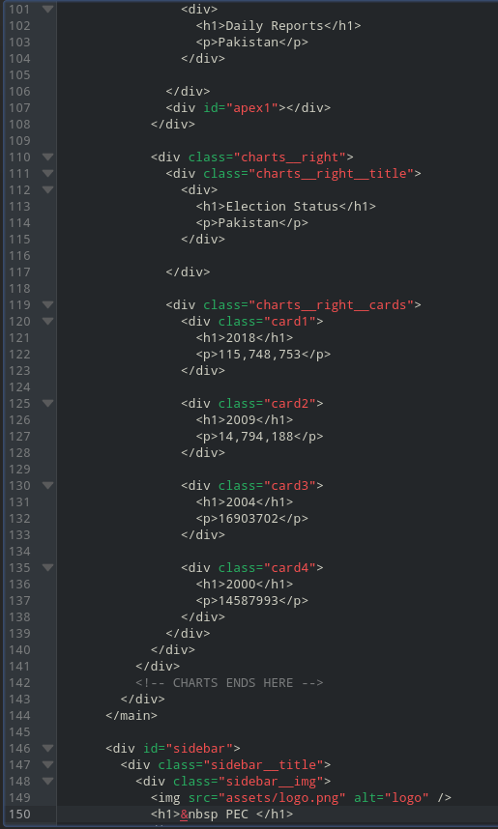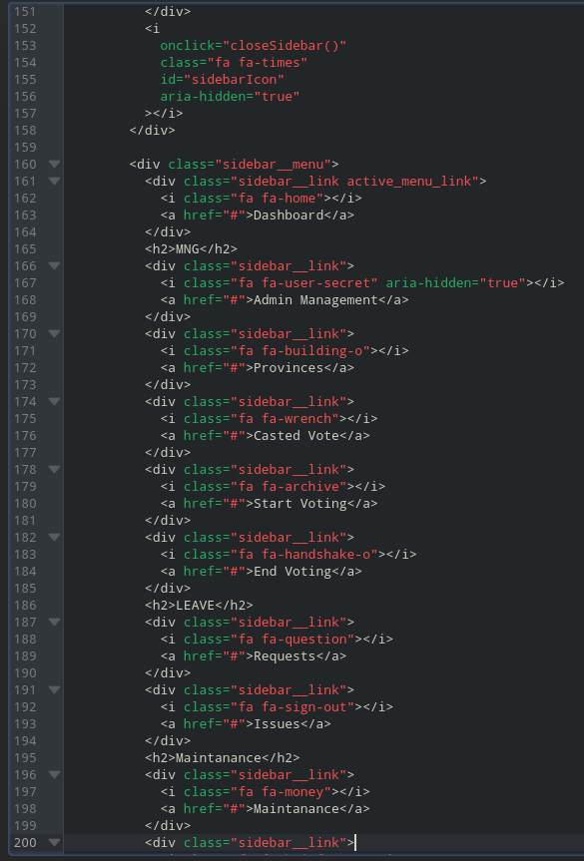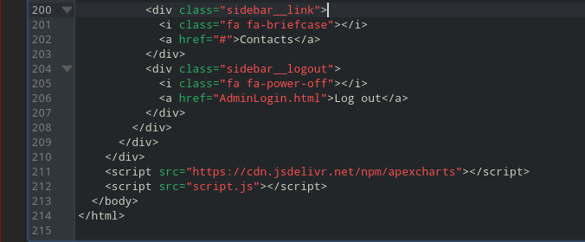

**CSS Code:**

